**Monarch Model Notes Vol. 2**

I started a new set of notes when I started using the USGS supercomputing cluster, because my old notes were reaching critical mass.

**August 1, 2016, Monday**

Had conference call last week with USGS in Denver.

**August 8, 2016, Monday.**

I’ve run 2 sims on Yeti. I think I have a workflow down, but there are some minor things I would rather change. I have to delete the output files on Yeti each time, so they are not saved there, unless I move them to another folder. The output combiner doesn’t work unless I delete the old output files.

I’m not using Git correctly, but that is secondary.

Also I can copy the model jar to Yeti from my laptop with Git, but can’t figure out how to copy it back with Git, so I used PuTTY lol. But I have it.

I brought in the text output files to R. There are only 8570 rows for sim 151. I think it should be 37165*10 instances = 371650 rows. I sorted data and there are 10 rows for each ID number, but only 857 ID nos. Did I use the Farm Prog Show shapefile? That must be it because FarmProgressShow5 has 857 polygons.

Problem with ./outputcombiner could be with file links. The Yeti OS is Scientific Linux (use command lsb_release –a).

Second simulation has 17140 rows = 857*20.

**August 10, 2016, Wednesday**

Everything seems to be right with sim 153. 743300 rows in cumeggszone file. Was only 1,000 agents, so need to try 10,000 agents.

Could ask Brad about whether to use 50 agents per task and 200 tasks/400 cores or use more agents per task. Also could ask about VM argument for Java.

Submitted a model on YETI with 400 cores. See how it goes, maybe email Brad tomorrow to see how he wants it handled.

I forget everything I was doing for sensitivity analysis. I think there were about 4 parameters I want to look at:

* Egg Density in MWROW60-100 and Grass/Pasture
* Utilization Distribution Area
* Mean Eggs Laid or something similar

Also have to decide whether to look at means or medians.

**August 11, 2016, Thursday**

Getting back into the R code. I plan to write up the workflow for each analysis to make the code easier to remember and understand.

I moved workflow write-ups to the end/appendix.

**August 15, 2016, Monday**

Had trouble though. Working in dbbmms153.RData on speedy2. Speedy2UD script won’t work, problem constructing allmons list, error about row.names. The problem was a simple problem, didn’t get names vector created correctly, so got a row.names error when tried to creat allmons list.

For run 153, got an error at 394th or 395th dbbmm and it stopped. Further investigation shows that allmons_t[395] is the problem, the monarch stayed in one or two raster cells the entire time. Monarch is M19. Never had that error before, I don’t think. Anyway, skipped it and did the rest.

**August 16, 2016**

Got areas off speedy2 for run 153. Should check against similar runs.

Run 153 was LHS 2, which was originally run as 91 and 92, then checked as 146 and 148. I concluded that I ran LHS 2 correctly (May 17, 2016). What workspace are the graphs saved in? Well, when checking up on it in CheckDir.R, I didn’t graph UDs, I graphed mean prop eggs laid. UD for 91 is in workspace Mon11.

|  |  |  |  |
| --- | --- | --- | --- |
| **Run** | **Mean** | **Pop.SD** | **Median** |
| **91** | 627.9 | 267.2 | 621 |
| **153** | 616.6 | 257.4 | 609 |

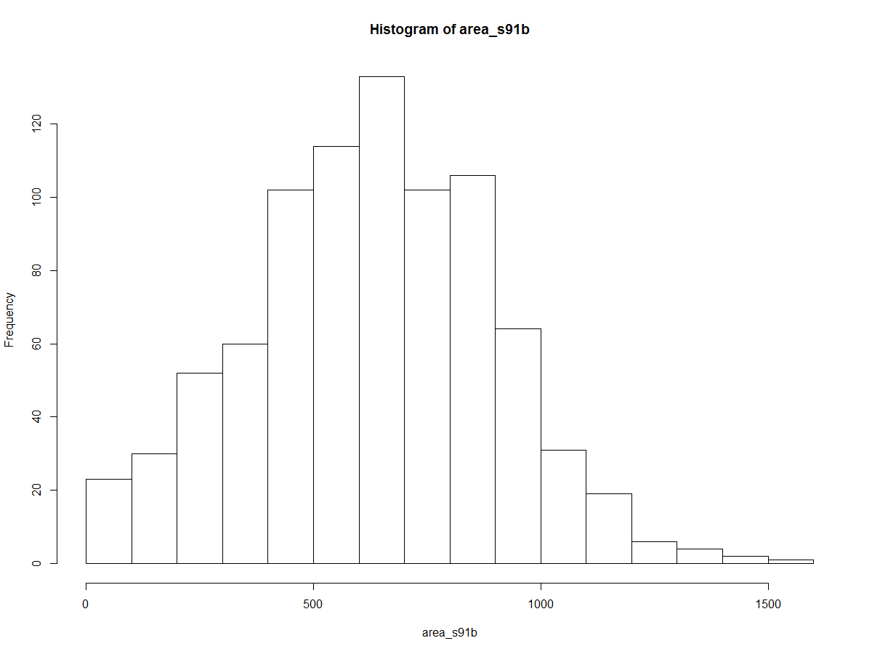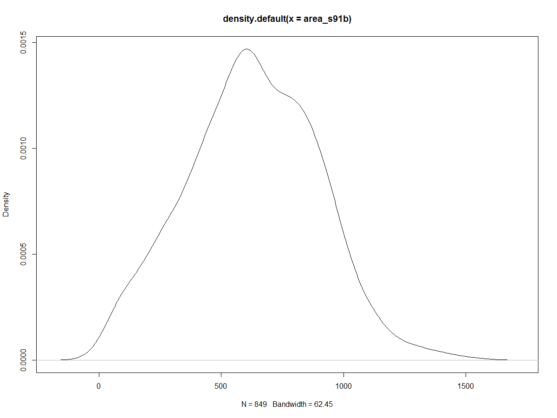

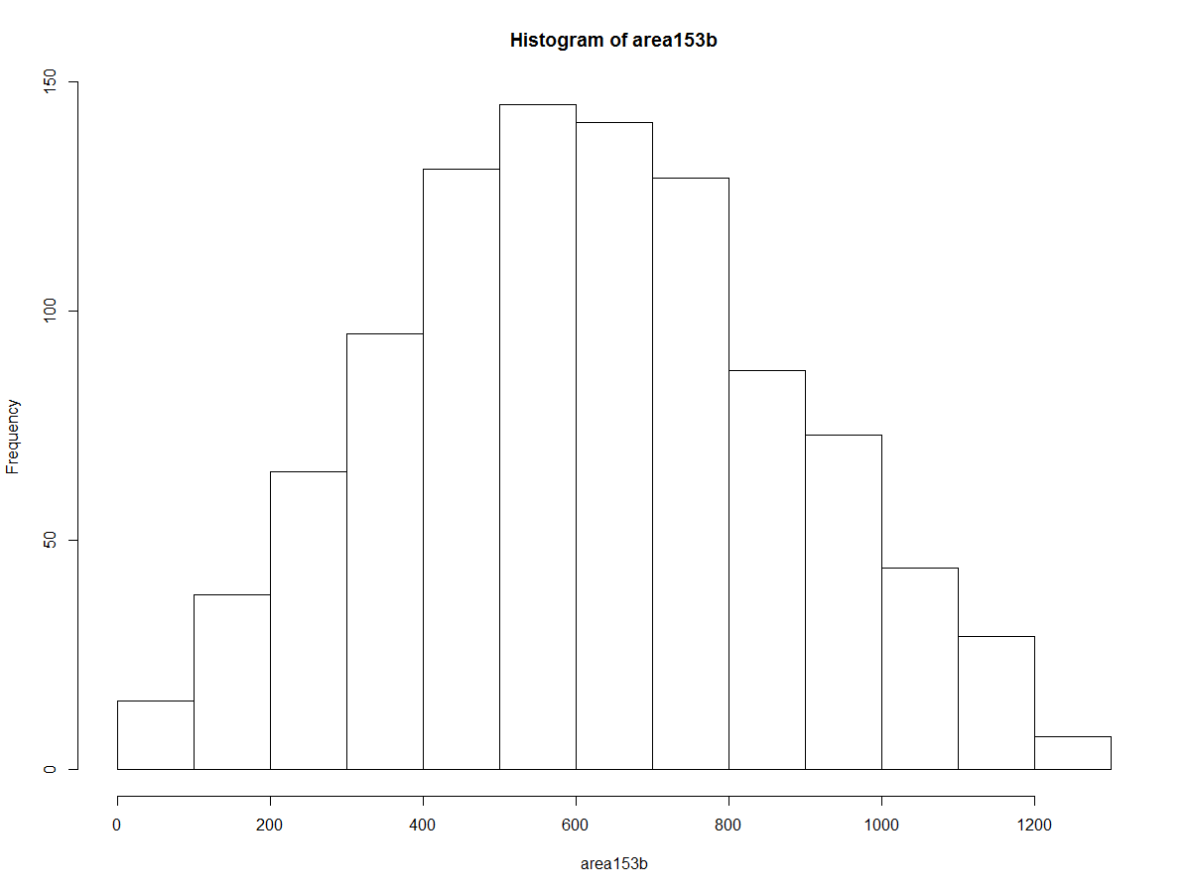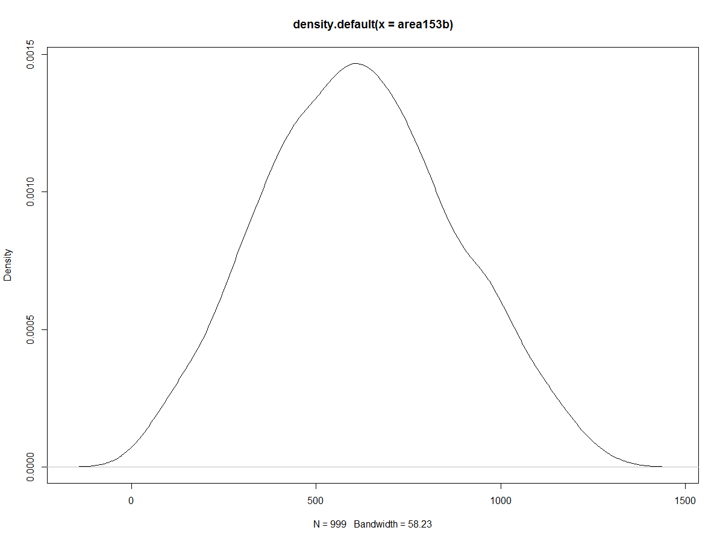

Conclusion – Run 153 worked successfully.

**August 17, 2016, Wednesday**

Heard back from Brad Williams, he didn’t think number of agents per core was much of a concern. Submitted a job using 100 cores instead of 400.

**August 18, 2016, Thursday**

Got email from Brad, trying to work out how to submit jobs to Yeti. The main issue is lines in the parm file, at this point.

Checked distr of area153, looks like it is all good compared to area91 from speedy2.

Now need to develop code for mean prop eggs laid.

**August 19, 2016, Friday**

Talked to Eric Tatara on the phone today. It was very good. He likes the model and says that there is something about it he has never seen before (I think he said all the mutually exclusive polygons, but can’t remember) and it’s in good shape. He had a few recommendations:

* Change Math.random() to the Repast randomhelper() method because it uses the random seed from the input, instead of a completely random number, so that simulations can be compared.
* I asked if he knew a better place for defining the equalarea CRS and he said he would try it. He said it would definitely be better to have it outside the while loop.
* He said the display network has no point when batch running, so I could find a way to turn it off (something I had in my notes to do). The runenvironment.batch() method finds if the model is being run as batch or not, and so can turn off display network code if its batch running.
* He asked if I’d done any profiling on it, which figures out which parts of the code are taking the most time. I said I hadn’t and didn’t know how, so he said he would do it real quick and send me results.
* I asked about random population of an irregular shaped shapefile. After some discussion, we decided the best thing to do might be to proportionally assign them to zoneagents, which I understand the concept but it would take a while to figure how to program. Might end up putting them in the center of polygons, but that’s the tradeoff.

**August 26, 2016, Friday**

I ran a 200 agent x 50 line simulation and it terminated at 24 hours, unfinished.

I tried the outputcombiner to see what I got, so I had something to play with until another simulation finishes.

I thought about running 100 agents x 100 lines = 200 cores and created the complete_model.jar for it, but I don’t think it will get through, especially since there is a 20 node job in the queue.

So I’m going to run 200x50 =100 cores again, but for 48 hrs.

I may as well start running more on speedy2, since it is pretty empty right now.

I guess I’ll start re-running LHS 1 on speedy2.

**September 8, 2016**

Trying some different things on Yeti. Running small sims while I try them. Adding -4046M to vm arg and using space-separated list for agents per instance.

Still biggest problem is finding data folder.

Maybe I need to erase everything that comes from extracting complete_model.jar, because maybe there is some sort of link I don’t know about.

Wouldn’t run – not sure if because of number of cores or VM arg.

So trying new one with 10 lines and VM -512M (still run 163)

**September 14, 2016, Wednesday**

**ICE**

Getting ready for ICE talk. Adding in results from when all probEggs=0.1. Had to track it down from last spring. It was runs 41 (1,000 agents), 42 (10,000 agents), and 49 (20,000 agents). I mapped it in Test shapefile.mxd.

In R, the script is in Monarchs.R starting at line 1478. The workspace in Mon2.Rdata.

Joined run 42 and 49 for regression. I want a predicted plot. The diagnostic plots are interesting because there is so much data. I should go through them to understand better what they mean.

Had a ridiculous problem trying to get predict() to work – problem was with matching names of original to name in data.frame for values to predict from. Anyway, seems to work now.

**October 10, 2016, Monday**

Returned from ICE. After discussions there, Steve and I decided a few things.

1. Drop 10m sims for now.
2. Try some sims with probeggs split up.
3. A few other things…to be added

So first need to do LHS again without 10m sims. Code is at the bottom of Monarchs.R, not the MonarchGlobalSA.R file.

Workspace is called LHS.RData.

I forgot I had to have the same number of parm possibilities for each parm, so I’ll just replace 10 with 40m step length:

|  |  |  |  |  |
| --- | --- | --- | --- | --- |
| **Parm** | **1** | **2** | **3** | **4** |
| Step Length | 20 | 30 | 40 | 50 |
| Remembered | 0 | 10 | 40 | 100 |
| Perception | 50 | 100 | 200 | 400 |
| Directionality | 0.1-0.2 | 0.1-0.9 | 0.5-0.75 | 0.8-0.9 |

Will probably need more augmented LHS combos, but have 15 for now.

**October 11, 2016, Tuesday**

YETI is out for another week. Running sims on speedy2 with 40 m step length instead of 10.

**October 13, 2016, Thursday**

When I get back and start running things on YETI again figure out how to add memory to Java command because it has a large effect on speedy2.

Starting to analyze new runs. I’m going to work out of the Monarchs output folder but continue to use YETIsims.R. I’m not going to delete old code from previous sims from this .R file for now. Saved the workspace as NewLHS.RData.

**October 17, 2016, Monday**

Running a sim and starting a bunch of UD runs. Probably go home early, not feeling well.

Got 6 UDs running, 174-184.

Run 176 got an error and stopped.

**October 20, 2016, Thursday**

Been sick.

Run 180 stopped. No. 129 seems to be the problem. A bunch of other ones stopped also. The error is always grid not large enough. Online found that this a new error for a new version of package move that is fixed by changing the ext option.

Default ext is 0.25 or a 25% increase in the bounding box. I’m going to try 0.5 and then higher with run 176, since it failed on 13th run.

Started running them all with ext=0.5, which is now in the speedy2UD script.

0.5 wasn’t enough for 184[[223]]

So changed it to 0.75.

Up to ext=2 and it doesn’t seem to affect the speed of the calcs.

Moved area182 into RStudio NewLHS.RData workspace. It’s very well –conditioned.

I’m going to move the dbbmms into a different workspace because they are so large.

**October 21, 2016, Friday**

Some UDs finished. I had to save 174 as a workspace (run174.RData) to return to it after vacation.

Also run176.RData

**October 31, 2016, Monday**

Speedy2 is full today, so worked on YETI. Found a place where I should have had a space that probably caused it to fail before (n20 instead of n 20). So a test run is running now and works. It took about 12 mins to run.

I added “-Xmx8092M” to the end of the load module Java command in slurm.repast and it seemed to work. It ran in any case.

**November 1, 2016, Tuesday**

The run I started on YETI was getting GC overhead limit exceeded on a bunch of instances. Also discovered –xmx was in the wrong place. Looks like it goes in the repastwrapper.sh file. So I canceled the job, which was running very slowly (only 3 ticks in 16 hrs) using command scancel …. Realized I need to change the option in slurm_repastwrapper.sh though…………………..

I tried n 40 but failed, so back to n 20. I think n has to match the number of lines in the unrolledParm.txt file. No that’s not right because it was running 10 instances, or 20/2=10. So I need n 40 for 20 lines. Trying again.

Seems to work now with 40 cores, 20 instances/lines. Well then didn’t work. Sent email. Also ran it again.

Speedy2 still full up with hentzel’s stuff.

**November 2, 2016, Wednesday**

Ran a sim on speedy2 and started a bunch of UDs. Still can’t get a sim to run right on YETI, but did get a 40 core sim to run, but forgot I deleted data folder… >:(

**November 3, 2016, Thursday**

YETI sim worked!

I’m moving Yeti sim results to /output folder where other output files are to keep R workspace in the same folder (instead of C:\Users\tgrant\Documents\Monarch Butterflies\Modelling with Repast Simphony\YETI output).

EggDensR6 is removing 4273 rows for stat_boxplot. Need to get to the bottom of that. Also removed 474 rows in EggDensGP.

Turns out the issue is that if I set ylim, then any values outside that are removed. So just outliers outside plot area are being removed.

**November 4, 2016, Friday**

Trying 80 cores on YETI with run 197 and 1000 agents. There are two things to try – n and c. First trying –n80. The slurm.repast file has 2 cores per task, so… It ran 40 instances but not all of them have stuff in them. 11 instances finished up immediately. I canceled it after 4hours because couldn’t figure out what was wrong. All instances I with data were done. Anyway, I’ll download it and see what it looks like.

It ran a total of 13,856 rows, so it apparently was running something more. It should only be 10,000 rows. So could use it but I’m afraid of getting confused and figuring out which ones ran full, etc. So tried below:

So I guess I need to do –n40 –c4. I tried “sbatch –n40 –c4 slurm.repast”. That requested 160 cores, realized it needs to be different and did this: “sbatch –n20 –c4 slurm.repast”. Because 20 tasks, and 4 cores per task = 80 cores.

Try 40 instances with 25 agents each in the future and see which goes faster.

Next week – generate 10 new augmented LHS combos. Figure out how to analyze directionality with prcc or something similar. Prepare for Nov 17-8 meeting. The fun thing is running more sims and sending a graph to Steve. Make a doc to summarize things for Steve.

**November 7, 2016, Monday**

Apparently YETI run 197 ran as –n10, -c2 when I tried to run –n20 –c4. I don’t know why. So apparently I need to run more instances instead of more cores. Run197.

It ran 2 runs per instance and seemed to just add the new data to the end of the previous data, so only 1 text file for 2 runs, but text files are twice as large as normal.

For run 200, just ran same thing again as run 197, but did normal –n40 –c2. Now I can compare it to run 197 to see if they are the same.

Need to add 10 more LHS combos. Original code is still in Monarchs.R and in workspace LHS.Rdata (in C:\Users\tgrant\Documents\Monarch Butterflies\Modelling with Repast Simphony\Output from apr28 and prev).

Tried to figure out the maximum possibilities, but my brain is too fried. Should be 4*4*4*4=256.

I sorted through run 197 Monarchs.txt and it looks like they are all different. But only way to tell for sure is run UDs and see if any are identical. But I bet it is fine.

**November 8, 2016, Tuesday**

I accidentally failed to write dbbmms197.RData, but got area197.RData.

Sent update to Steve today.

**November 10, 2016, Thursday**

Talked to Steve today. Things to do:

* Finish sensitivity analysis
  + Run about ~20 then check how fast confidence intervals are decreasing by running each sample size.
* Find some illustrative home ranges that show how perception distance is decreasing UD.
* Calculate prcc for directionality
* See if I can extract x,y dimensions of UD and distance from birth to death.
  + Hazel’s paper doesn’t say exactly how she calculated birth to death distance. Not sure if faster to do in RS or R.
  + Steve would like the birth to death distances
* Read NRCS modeling thing Steve sent
* Run model with Hazel’s approach – separate probeggs into 2 probs. Do this last.
* To write paper, talk with Steve paragraph by paragraph – make an outline, about how we want to lay it out.
* I should test UD calcs when step length is 20 and raster is 30. Or basically test raster size more. It’s probably fine though.

**November 15, 2016, Tuesday**

Looking at units of volUD. Raster size is 30m x 30m, because I set raster as 30, and map units for aeqd are meters.

Looking into how to get distance between birth and death locs. There is a command in move called coordinates that extracts all the coordinates from a move object. So I could take first and last of those, which are in lat/long and use Pythagorean Theorem to calculate distance between. Curvature of the earth shouldn’t matter at this scale.

Illustrative home ranges: LHS10, run 192, has step length 20 and perception distance of 400, so should be interesting to look at.

I like number 739 of run 192 because it shows it getting stuck:

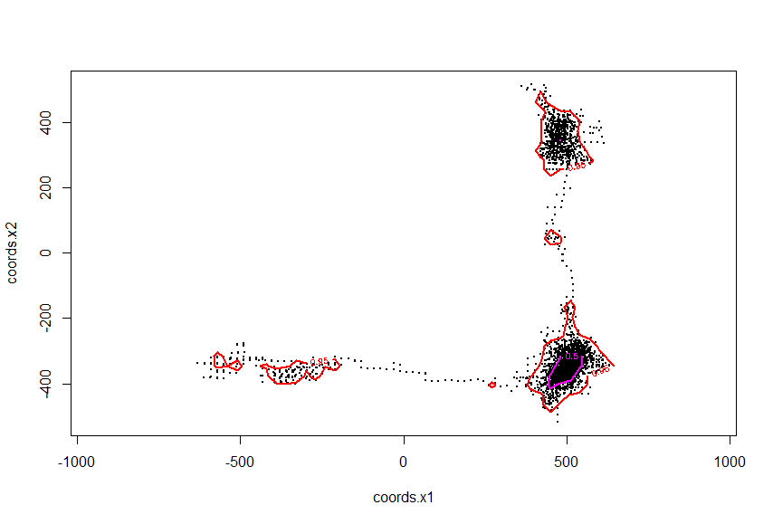

**November 16, 2016, Wednesday**

Finally ran LHS12 on speedy2 just to get it done.

**November 28, 2016, Monday**

To do:

Finish 25 sims.

Check Marino 2008 again and see if I need a regression to predict change in UD size from variables.

Look at code to start seeing how to separate out probeggs and probchoice.

There’s no good “correlation” for categorical variables, so a regression is the best thing to do, which I want to do anyway to get some idea of the predicted change in response variables.

**December 5, 2016, Monday**

To do: scatterplots of input and output variables from simulations to see if linear, etc.

Also check if any of input variables are correlated. Well they can’t be, they’re randomly chosen.

Also try rank=FALSE for PRCCs.

SSAR.

So pcc, prcc are very similar (at least for UDs), as are src, srrc. So which to use…

Can SRCs be calculated for categorical vars? I don’t think so.

**January 25, 2017, Wednesday**

**SPLIT PROBEGGS**

Saving old code in a Word file.

New parms will be probMove and probEggs, probability of moving toward a polygon and prob of laying eggs when in that polygon.

Adding probMove to shapefile first.

Current shapefile: StoryCoB19_sp.shp

New shapefile: StoryCo_probMove.shp

New probMove values are in Documents\Monarch Butterflies\Model Parameters\Monarch Model Parameters.xls.

-Successfully loaded new shapefile into RS.

-Saved old code to Documents\Monarch Butterflies\Modelling with Repast Simphony\Monarch Code before probMove.docx

Don’t forget to change range of probEggs/probMove for directionality- I should program this in. Program in as entered value.

I use Math.random(), which I think is ok, since randomhelper is usually for repeating simulations with a given set seed.

Cleaned up code and removed a lot of commented out stuff.

Got it running fine with probMove, wasn’t so difficult. Was running testing and found a small bug though. It probably rarely came into play before, but comes into play a lot now because they are staying in corn field so often. When they come within sight of polygons, after doing corr rand walk outside of sight of other polygons, and then choose current polygon, as often happens now, they don’t keep moving in the direction they were moving before. It’s using the wrong initial angle to calculate the corr rand walk. See this screen shot:

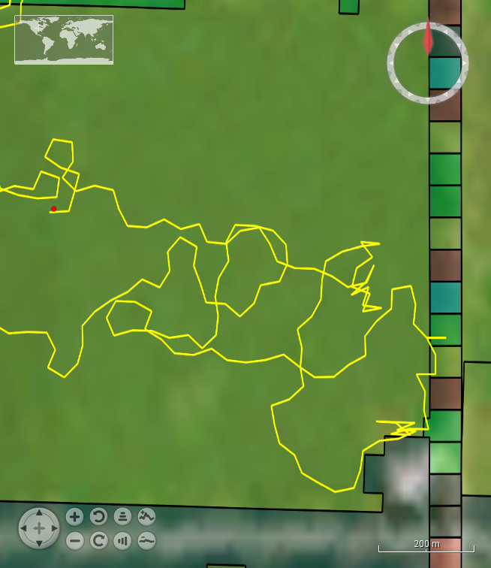

So changed both corr rand walks to used “lastAngle”, which is last angle ever moved. Paths look much better, but still go into corn a lot more.

Now running a small simulation before a big one – it’s in Sensitivty Analysis spreadsheet, run 229, using parameters from LHS9 – step = 30, rem = 0, per = 50, dir = 0.5-0.75.

I ran all the sims was dismayed that eggs laid in run 233 was less than LHS9. I wasn’t thinking correctly, and thought it should be the same. So ran run235 and run236 with lastAngle changed back to how it was before. But the prop eggs is slightly less in run 233 than LHS9 because probEggs is less.

However, run232 does have a smaller UD than LHS9, which shouldn’t be right. So I need to calc UDs for when lastAngle is changed back to the not-quite-correct corr rand walk situation.

Uds for run234 are running.

On Monday, if run234 is similar to LHS9, keep it and use run236 as well.

If run234 is NOT like LHS9, then its just randomness and I can use whichever one is closer for clarity. Can use run232 or run234 for UDs and run233 or run236 for the other stuff. Probably will use run236 in any case.

So to SUMMARIZE:

Runs 229-236 were to test splitting probEggs into probEggs and probMove. I compared test case 1 and test case 2 to LHS9. The Model Parameters spreadsheet has the values for probEggs and probMove.

During testing I noticed I needed to change currAngle and currAngle2 in the corrrandwalk methods to lastAngle, so correlated random walks occur smoothly. I used this new code for test case 1. However, this may slightly affect movement behavior so I changed it back for 234-236 (test case 2), but in the future I will use it, because it’s definitely better, though probably only a slight effect.

229 was a test run. 230 was 10,000 with probMove varying (test case 1). 231 was coords for same thing as 230 (test case 1). 232 was coords with probEggs varying (test case 2). 233 was 10,000 for test case 2.

234-236 are also test case 2 with but with correlated random walk changed back to old way.

In the end, I used 230 and 231 for test case 1, and 234 and 236 for test case 2.

I also changed corr rand walk back to the way I like, but if I run models again I should double check that, and the input shapefile.

**March 27, 2017**

Creating figure for MS. Subset out small area of St Co to run in RS for figures. Four square mile sections with buffer. 14,043,652.8 m2 = 1404.4ha = 3470.3 acre = 5.4 sq mile. 518 polygons.

Eliminated everything under 2274 m2.

Added in probEggs AND probMove.

Lat/longs for boundaries, etc.

Mid lat/long for network initialization: -93.35, 42.1

*Corners, ½ mile outside (measured in ArcMap):*

SW corner: 42.08, -93.38

SE corner: 42.08, -93.31

NE corner: 42.13, -93.31

NW corner: 42.13, -93.38

*Corners, slightly inside, measured in ArcMap:*

SW corner: 42.09, -93.369

SE corner: 42.09, -93.327

NE corner: 42.1247, -93.327

NW corner: 42.1247, -93.369

Now is a good time to test boundary bounce and see if something is happening.

Got it into RS and errors in the display. So need to do another subset that has fewer polys and do singlepart to multipart.

Also tried to get GIS 2D display to work, but can’t get it to work.

So making new shapefile. FFS.

Clip, Multipart to singlepart, eliminate, add probEggs and probMove, project to correct folder, move to /data folder

472 polygons, 12,742,942.049 m2 = 1274.3 ha = 4.92 sq miles

Find coords:

Mid lat/long for network initialization: -93.45, 42.18

*Corners, ½ mile outside (measured in ArcMap):*

SW corner: 42.157, -93.474

SE corner: 42.157, -93.411

NE corner: 42.207, -93.411

NW corner: 42.207, -93.474

*Corners, slightly inside, measured in ArcMap:*

SW corner: 42.165, -93.4646

SE corner: 42.165, -93.4234

NE corner: 42.198, -93.4234

NW corner: 42.198, -93.4646

|  |  |  |  |  |  |  |
| --- | --- | --- | --- | --- | --- | --- |
| **Snapshot** | **Perception Dist** | **Remembered** | **Step length** | **Dir** | **No. Mons** | **Ticks** |
| A | 50 | 10 | 30 | 0.5-0.75 | 1 | 10 |
| B | 50 | 10 |  |  | 1 | 10 |
| C | 50 | 10 |  |  | 1 | 10 |
| D | 100 |  |  |  | 1 | 10 |
| E | 75 |  |  |  | 1 | 10 |
| F | 50 |  |  |  | 1 | 10 |
| G | 75 |  |  |  | 3 | 10 |
| H | 100 |  |  |  | 3 | 10 |
| I | 50 |  |  |  | 3 | 10 |
| J | 100 |  |  |  | 25 | 7 |
| K | 50 |  |  |  | 25 | 5 |
| L | 400 |  |  |  | 1 | 10 |
| M | 400 | 100 |  |  | 1 | 10 |
| N | 50 | 10 | 30 | 0.1-0.9 | 1 | 10 |
| O | same as N… |  |  |  |  |  |
| P | same as N… |  |  |  |  |  |
| Q | 50 | 10 | 30 | 0.1-0.2 | 1 | 10 |
| R | same as Q… |  |  |  |  |  |
| S | 50 | 0 | 30 | 0.5-0.75 | 1 | 10 |
| T | same as S… |  |  |  |  |  |
| U | same as S… |  |  |  |  |  |
| V | 50 | 100 | 30 | 0.5=0.75 | 1 | 10 |
| W | save as V… |  |  |  |  |  |
|  |  |  |  |  |  |  |
|  |  |  |  |  |  |  |

Figure 5 combos:

|  |  |  |  |  |
| --- | --- | --- | --- | --- |
| **Panel (Snapshot)** | **Perceptual Range** | **Spatial Memory** | **Dir** | **Step length** |
| A (C) | 50 | 10 | 0.5-0.75 | 30 |
| B (D) | 100 | 10 | 0.5-0.75 | 30 |
| C (L) | 400 | 10 | 0.5-0.75 | 30 |
| D (M) | 400 | 100 | 0.5-0.75 | 30 |
| E (P) | 50 | 10 | 0.1-0.9 | 30 |
| F (R) | 50 | 10 | 0.1-0.2 | 30 |
| G (U) | 50 | 0 | 0.5-0.75 | 30 |
| H (W) | 50 | 100 | 0.5-0.75 | 30 |

Reformed Figure

|  |  |  |  |  |
| --- | --- | --- | --- | --- |
| **Panel (Snapshot)** | **Perceptual Range** | **Spatial Memory** | **Dir** | **Step length** |
| A was G (U) | 50 | 0 | 0.5-0.75 | 30 |
| B was C (L) | 400 | 10 | 0.5-0.75 | 30 |
| C was H (W) | 50 | 100 | 0.5-0.75 | 30 |
| D was D (M) | 400 | 100 | 0.5-0.75 | 30 |
| E was E (P) | 50 | 10 | 0.1-0.9 | 30 |
| F was F (R) | 50 | 10 | 0.1-0.2 | 30 |
|  |  |  |  |  |
|  |  |  |  |  |
| A (C) | 50 | 10 | 0.5-0.75 | 30 |
| B (D) | 100 | 10 | 0.5-0.75 | 30 |

For egg density figure, LHS18 seems best. Working in .mxd MS-UDfigs – LHS18.mxd.

**R Workspaces**

Mon1 – original, some graphs, UDs for run 33

Mon2 – UDs for run 38,45,46,47, and **86**. Pub graphs for **step length** UDS, pub graphs for egg density by **step length**, boxplots for individual habitat type egg density by **step length**

Mon3 – UDs for run 56

Mon4 – UDs for run 52, 75 – 10m step by perception

Mon5 – UDs for run 58, 60, graphs for **remembered** UDs, bbmm testing, **remembered** egg density graphs

Mon6 – UDs from run 65, 61, 64 graphs for **perception** UDs, **perception** egg density graphs

Mon7 – UDs from run 70, 45, 71 – note that dbbmms45 here is from speedy2, I accidentally overwrote it. I had already calculated the area45 and area_s45 though, so those are from my PC.

Mon8 – UD for run 45 from speedy2

Mon9 – UD graphs for runs 80, 81, 84, 38, which is **directionality**. Also egg density graphs for **directionality**.

Mon10 – egg density for run92, 76-78, 104-105, UD for 95, MEAN PROPORTION OF EGGS LAID graphs, lhs8 egg density, checkdir for lsa and lhs combos.

Mon11 – UDs for runs 89, 91, 93 – only i=149-1000, also UDs for run99, run97

NewLHS.RData – sensitivity analysis starting Oct 10 without 10m step length

**Workflows**

***Simulations on Speedy2***

Can run simulation right from Repast Simphony. Click green button to open model then yellow button for batch runs.

The host properties should look like so:

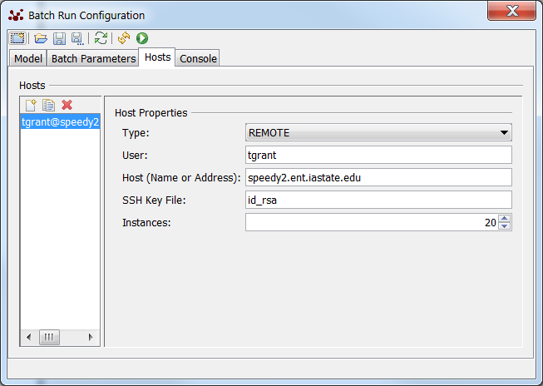

Check how things are going with <http://www.biology-it.iastate.edu/status/speedy2>

Or log in to speedy2 using PuTTY and my ISU credentials (same as for email, etc.). Use commands top or atop to see how the cores are doing. Press Q to get out of top.

If the connection from RS to the server is lost, you have to go through several steps to get the output files. The simulation will finish and the output files will be in their individual instance folders. You have to copy jsch-0.1.48.jar to the lib directory of the simulation. This jar is normally in C:\RepastSimphony-2.3.1\eclipse\plugins\repast.simphony.distributed.batch_2.3.1\lib. I copied it to Downloads folder to move it easier using pscp. Then the scripts have to be activated as it describes in the batch runs .pdf, using the command chmod +x *.sh. Then the outputcombiner can be run, from the folder where you can see the instance folders and lib folder, using ./outputcombiner.sh. Then use pscp to copy the combined_data folder from the server to my laptop:

"C:\Program Files (x86)\PuTTY\pscp.exe" –r tgrant@speedy2:/home/tgrant/simphony_model_14etc/combined_data/* C:\Users\tgrant\Downloads\.

***Egg Density per Polygon Workflow***

Import the CumEggsPerZone text output file from the simulation. The “Denresults” dataframe combines all the data for each polygon, because there is independent data from each simulation. Various statistics are added to the dataframe for each polygon.

Extract just the data on each habitat type from Denresults. For sensitivity analysis, I’m just doing MWROW60-100 and Grass/Pasture. Look at the distribution of egg density per ha for polygons of each habitat type and calculate mean, median, SD, etc.

Start a graph that will show mean and median egg density per habitat type, per simulation.

Throw mean and medians into response variable vectors for global sensitivity analysis script file (a separate file).

***Utilization Distribution workflow***

*To run on speedy2:*

Copy the coords output file to speedy2 using pscp from the Windows Command Prompt:

"C:\Program Files (x86)\PuTTY\pscp.exe" C:\Users\tgrant\Downloads\file tgrant@speedy2:/home/tgrant/R/.

Login to speedy2 with PuTTY and ISU login credentials. Find speedy2UDscript.R in Yeti output folder on my computer (C:\Users\tgrant\Documents\Monarch Butterflies\Modelling with Repast Simphony\Output from apr28 and prev).

Follow speedy2UDscript.R workflow.

Create R objects of dbbmms and areas and copy them from speedy2 using pscp. (Only really need to copy the area, can copy dbbmms if need to check up on things.)

***Mean Eggs Laid Workflow***